Experiment no 1

Aim: Apply fundamental design principles to create a visually appealing and user-friendly frontend interface using HTML and CSS.

Theory:

Introduction on to HTML and CSS

HTML (HyperText Markup Language) and CSS (Cascading Style Sheets) are the fundamental technologies used for creating web pages. HTML structures the content, while CSS enhances its presentation on and styling.

- HTML (HyperText Markup Language) Definition:

HTML is a markup language used to create the structure of a web page. It consists of various elements that define headings, paragraphs, images, links, tables, and other components.

Features of HTML:

Simple and easy to learn

Platform independent (works on all browsers and devices) Uses a tag-based syntax
Supports multimedia elements (images, videos, audio)

Allows linking between multiple web pages using hyperlinks

Common HTML Elements:

Tag | Description
<h1> - <h6> | Headings (largest to smallest)
<p> | Paragraph
<a href=""> | Hyperlink
<img src="" alt=""> | Image
<ul>, <ol>, <li> | Lists (unordered, ordered)
<table> | Table structure
<form> | Form for user input
<div> | Container for grouping elements
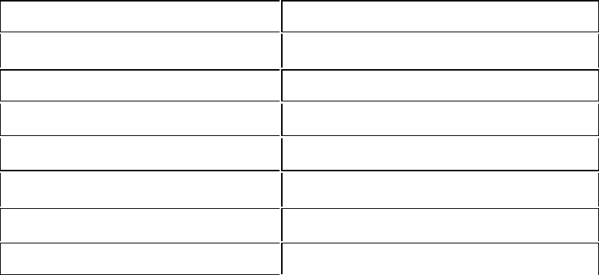

- CSS (Cascading Style Sheets) Defini on:

CSS is a stylesheet language used to control the appearance and layout of HTML elements. It allows web developers to design a rac ve and responsive web pages.

Features of CSS:

Separates content from design

Reduces code duplica on by applying styles globally Supports responsive design for diﬀerent screen sizes Allows anima ons and visual eﬀects
Improves page loading speed by reducing inline styling

Types of CSS:

- Inline CSS (wri en inside an HTML tag)

- Internal CSS (wri en inside the <style> tag in the <head> sec on)

- External CSS (linked through an external file)

Basic CSS Properties:

Property | Description
color | Sets text color
font-size | Adjusts font size
background-color | Sets background color
border | Defines borders around elements
margin | Sets space outside an element
padding | Sets space inside an element
display | Controls how elements are displayed
position | Defines element positioning
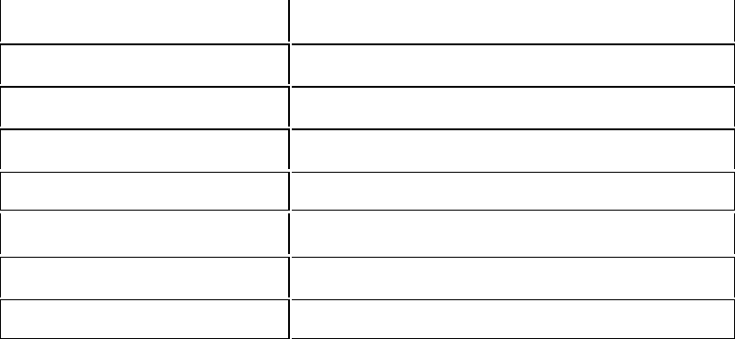

- Rela onship Between HTML and CSS

HTML provides the structure, while CSS styles it.

CSS can be applied to mul ple HTML files, ensuring a consistent design across all pages.

Using CSS makes it easier to maintain and update the website.

- Advantages of Using HTML and CSS
  - Easy to learn and implement
  - Enables responsive web design
  - Enhances user experience with styling and animations

  - Separates structure (HTML) from design (CSS) for better organization

  - Compatible with all modern web browsers
Code of HTML:

<!DOCTYPE html>
<html lang="en">

<head>
<meta charset="UTF-8">
<meta name="viewport" content="width=device-width, initial-scale=1.0">
<title>portfoli</title>
<link rel="preconnect" href="https://fonts.googleapis.com">
<link rel="preconnect" href="https://fonts.gstatic.com" crossorigin>

<link
href="https://fonts.googleapis.com/css2?family=Poppins:ital,wght@0,100;0,200;0,300;0,400;0,500;0,600;0,700;0,800;0,900;1,100;1,200;1,300;1,400;1,500;1,600;1,700;1,800;1,900&display=swap"
rel="stylesheet">
<link rel="stylesheet" href="style.css">
<style>
:root {
--headc: #384363;
--mainc: aliceblue;
}

* {
padding: 0;
margin: 0;
box-sizing: border-box;
scroll-behavior: smooth;
}

body {
background-color: var(--mainc);
color: var(--headc);
font-family: "Poppins", sans-serif;
font-weight: 300;
}

header {
position: sticky;
top: 0;
width: 100%;
height: 100px;
background-color: var(--headc);
display: flex;
align-items: center;
justify-content: center;

}

nav {
width: 100%;
display: flex;
justify-content: space-around;
align-items: center;
height: 100%;
padding: 0 20px;
}

nav h1 {
color: white;
margin: 0;
font-size: 40px;

}

nav ul {
display: flex;
justify-content: center;
align-items: center;

}

nav ul li {
list-style: none;
margin: 0 31px;
color: white;
font-size: 27px;
font-weight: 400;
}

.s1 {
display: flex;
justify-content: space-around;
margin: 23px 0;
}

.left {
color: var(--headc);
font-size: 2rem;
margin: 110px 30px;
}

.right {
margin: 50px 10px;
}

.pur {
color: blueviolet;
}

@keyframes typing {
from {
width: 0;
}

to {
width: 100%;
}
}

.typing {
display: inline-block;
white-space: nowrap;
overflow: hidden;
border-right: 2px solid black;
width: 0;
animation: typing 2s steps(8) forwards, blink 0.5s infinite;
}

nav ul li a {
text-decoration: none;
color: white;
}

nav ul li a:hover {
color: rgb(246, 15, 54);
}

nav ul li a:active {
border: 2px solid white;
padding: 5px 10px;
border-radius: 10px;

}

.cap {

font-size: 50px;
font-weight: 500;
color: black;
}

#contacts .contact {
display: flex;
flex-wrap: wrap;
list-style: none;
justify-content: space-around;
}

#contacts .contact a {
text-decoration: none;
color: var(--headc);
}

#contacts h2 {
font-size: 50px;
font-weight: 600;
font-family: "poppins";
padding: 50px 70px;
color: black;

}
</style>
</head>

<body>
<header>
<nav>

<h1>portfolio.</h1>

<ul>
<li><a href="#home">Home</a></li>
<li><a href="#skill">Skills</a></li>
<li><a href="#about">About</a></li>
<li><a href="#contacts">Contacts</a></li>

</ul>

</nav>
</header>
<main>
<section class="s1" id="home">
<article class="left">
<h2>Hi,</h2>
<h2>I am <span class="pur">Ajay</span></h2>
<h2><span class="typing">Web Developer</span></h2>
</article>
<article class="right">
<img src="profile.png" alt="dp" width="500px">
</article>
</section>

<section id="skill">
<h2>My Skills </h2>

<div class="skills-container">
<div class="skill-card">
<img src="react2.png" alt="React">
<figcaption>React</figcaption>
</div>
<div class="skill-card">
<img src="java.png" alt="Java">
<figcaption>Java</figcaption>
</div>
<div class="skill-card">
<img src="sql.png" alt="SQL">
<figcaption>SQL</figcaption>
</div>
<div class="skill-card">
<img src="python.png" alt="Python">
<figcaption>Python</figcaption>
</div>
<div class="skill-card">
<img src="c.png" alt="C Programming">
<figcaption>C Programming</figcaption>
</div>
</div>
</section>

<section id="about">
<article>
<h2>About Me</h2>
<p>
Hi, I’m Ajay Lakshawani, Web Developer, and Cricketer with a keen eye for detail and a drive to
create meaningful work.
With a strong foundation in Web Development, I’m always excited to take on new challenges and push
the boundaries of creativity.<br><br>

I believe that great work starts with understanding the needs of the client and the audience. My
approach is rooted in collaboration, clear communication, and a commitment to excellence. I strive
to deliver solutions that not only meet expectations but exceed them.<br><br>

If you’d like to collaborate or learn more about my work, feel free to reach out!
</p>
</article>
<figure>
<img src="pc.jpg" alt="About Me">
</figure>
</section>

<section id="contacts">
<h2>CONTACT ME </h2>

<ul class="contact">
<li><a href="https://github.com/AjayLakshawani" target="_blank">
<figure class="icons"><img src="github.svg" alt="github" width="170px">
<figure>
<figcaption class="cap">GitHub</figcaption>

</a></li>
<li><a href="https://www.linkedin.com/" target="_blank">
<figure class="icons"><img src="lindn.svg" alt="linkedin" width="170px" ">
<figure>
<figcaption class=" cap"> Linkedin</figcaption>

</a></li>
<li><a href="https://x.com/" target="_blank">
<figure class="icons"><img src="twitter.svg" alt="twitter" width="170px ">
<figure>
<figcaption class="cap"> Twitter</figcaption>

</a></li>
<li><a href="https://www.instagram.com/ajay_lakshwani_" target="_blank">
<figure class="icons"><img src="insta.svg" alt="instagram" width="170px ">
<figure>
<figcaption class="cap"> Instagram</figcaption>

</a></li>

</ul>
</section>

</main>
<footer>
<h4 id="footer">&copy; My portfolio 2025</h4>
</footer>
</body>

</html>

External css code

:root {
--headc: #384363;
--mainc: aliceblue;
}
#skill {
text-align: center;
padding: 40px 20px;
background-color: #f0f8ff;
font-family: "Poppins", sans-serif;
}

h2 {
font-size: 2rem;
color: #444;
margin-bottom: 20px;
}

.skills-container {
display: flex;
flex-wrap: wrap;
justify-content: center;
gap: 15px;
}

.skill-card {
background: white;
border-radius: 15px;
padding: 15px;
box-shadow: 0 2px 5px rgba(0, 0, 0, 0.1);
transition: transform 0.2s ease, box-shadow 0.2s ease;
text-align: center;
width: 150px;
border: 2px solid transparent;
}

.skill-card img {
width: 80px;
height: 80px;
object-fit: contain;
margin-bottom: 8px;
transition: transform 0.3s;
}

.skill-card figcaption {
font-size: 1rem;
font-weight: 500;
color: #333;
}

.skill-card:hover {
transform: scale(1.05);
border-color: #61dafb;
}

.skill-card:hover img {
transform: rotate(5deg);
}

#about {
text-align: center;
padding: 30px;
background-color: var(--mainc);
}

#about h2 {
font-size: 24px;
color: #333;
margin-bottom: 15px;
}

#about p {
font-size: 16px;
color: #555;
max-width: 600px;
margin: 0 auto 20px auto;
line-height: 1.5;
}

#about figure {
margin-top: 20px;
}

#about img {
width: 200px;
border: 3px solid var(--headc);
border-radius: 10px;
box-shadow: 2px 2px 10px rgba(0, 0, 0, 0.1);
}

/* Responsive Layout */
@media (min-width: 768px) {
#about {
display: flex;
align-items: center;
justify-content: center;
gap: 30px;
}

#about article {
max-width: 50%;
text-align: left;
}

#about figure {
max-width: 40%;
}

#about img {
width: 250px;
}
}

footer #footer{
background-color: var(--headc);
color: #f9f9f9;
padding: 5% 43% ;
}
Output:
